INTERDIGITATED ELECTRODES IN MICROFLUIDICS

Erin Ingram

**Band-Pass Filter Subsystem Report**

**Table of Contents**

List of Figures …………………………………………………………………………………..

List of Tables ……………………………………………………………………………………

1. Introduction ……………………………………………………………………………..

2. Theory …………………………………………………………………………………..

3. Design …………………………………………………………………………………..

4. Operation ……………………………………………………………………………….

5. Data Collection …………………………………………………………………………

6. Conclusion ………………………………………………………………………………

6.1 Learnings …………………………………………………………………………….

6.2 Future Works …………………………………………………………………………

**List of Figures**

Figure 1: Band-pass filter subsystem block diagram

Figure 2: Conceptual Scope of Band-Pass Filter

Figure 3: COMSOL simulations of electric fields with 5um IDE array

Figure 4: Bonded device, pre-soldering (band-pass filter device on bottom)

Figure 5: Device being operated under the microscope, equipped with tubing and wires

Figure 6: First stage of the band-pass filter, under the microscope

Figure 7: Second stage of the band pass filter, under the microscope

**List of Tables**

Table 1: Table of experimental results ……………………………………………………..

**1. Introduction**

The purpose of this report is to discuss the band-pass filter subsystem of the microfluidic parser, a microfluidic lab-on-a-chip device that uses interdigitated electrodes (henceforth, “IDE”) to perform size-based filtration of fluid droplets on the scale of microns. The bandpass filter sorts out excessively large and excessively small droplets from the desired medium droplet size, ~80 microns. This report will cover theory of the subsystem, design, operation, and data collection/analysis.

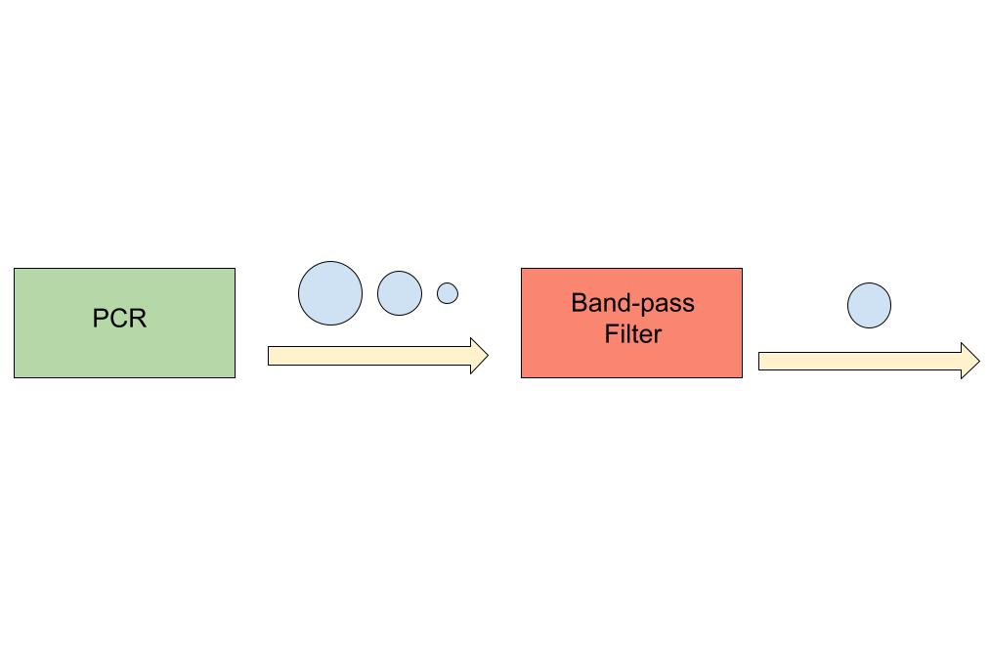

*Figure 1: Band-pass filter subsystem block diagram*

**2. Theory**

The scope of this subsystem is a physical channel for fluid to flow through as well as IDEs to perform filtration. Specifically, droplets >100 microns (waste) in diameter are sorted out in its first stage, and droplets >80 microns (hit) are sorted out in its second stage, allowing droplets <80 microns (waste) to pass through. This subsystem is a vital component of the device when polymerase chain reaction (PCR) is performed as an intermediate step in a microfluidics experiment, which is common. PCR results in varied droplet sizes and it is essential to experimental precision that unwanted droplet sizes are filtered out. In the experiments performed to validate the subsystem, water droplets are suspended in a diluted surfactant.

The IDE chosen for this experiment was a 5um array, meaning finger width is 5um and finger distance is 5um. This was partly chosen from COMSOL simulations and partly chosen from quality assurance during fabrication. The COMSOL simulation indicated that a 5um array would be sufficient to reach the droplets via electric field. Quality assurance during fabrication left limited options of IDEs to choose from.

The IDEs are powered by a function generator outputting a 5kHz 200mV sine wave. The generated electric field directs large and medium size droplets into outflow channels while small satellite droplets pass through unaffected. Large droplets and satellite droplets are sent to waste while the medium droplets are collected.

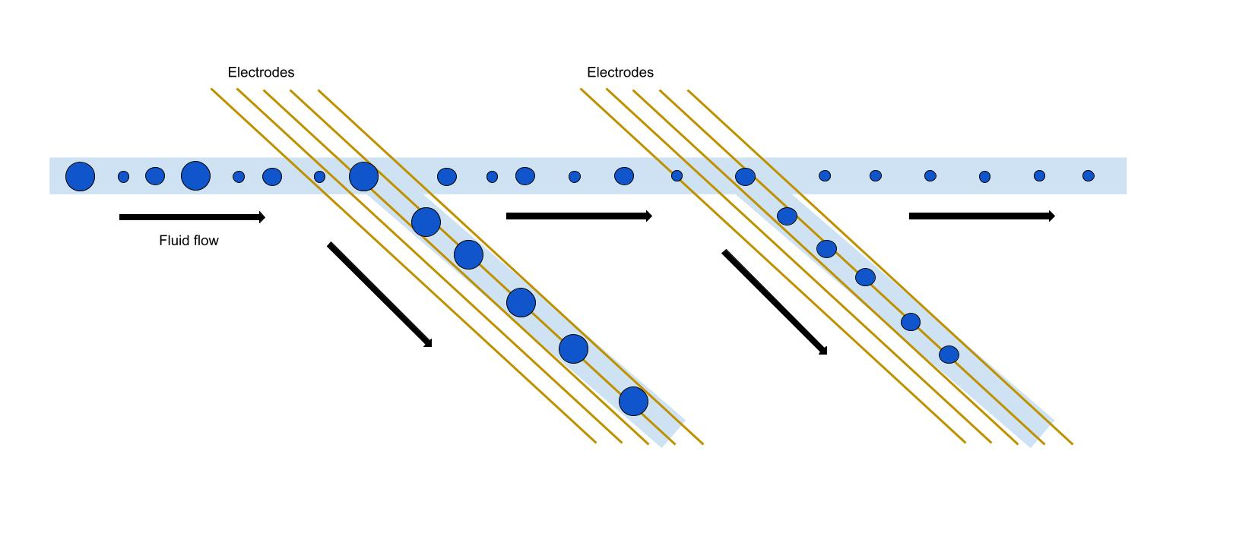

*Figure 2: Conceptual Scope of Band-Pass Filter*

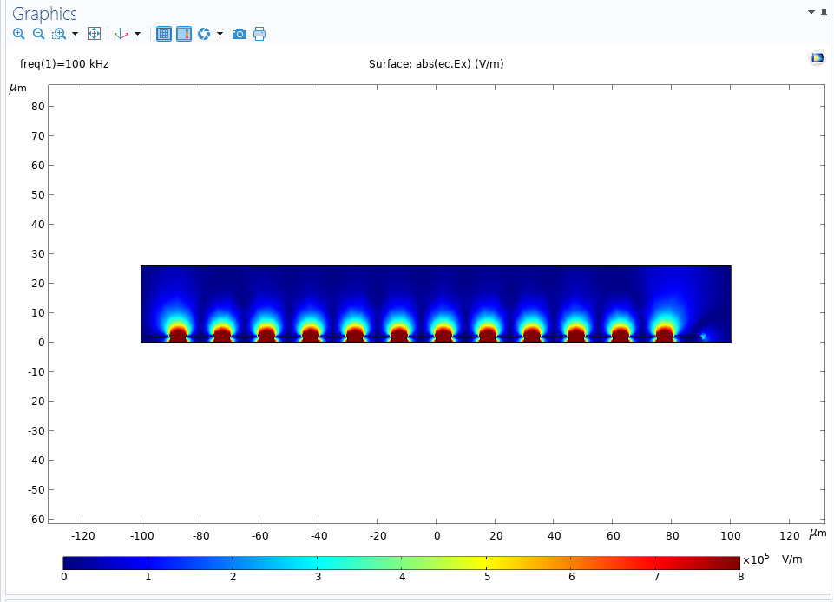

*Figure 3: COMSOL simulations of electric fields with 5um IDE array*

**3. Design**

First, microfluidic channels were designed in AutoCAD. The channel dimensions were designed to accommodate intended droplet sizes. The height of the output channels tapers down to help facilitate movement. Channel design is something that has already been researched and optimized in the field of microfluidics, so this is not the focus of innovation in this project. The channel was 3D printed onto a silicon wafer using NanoScribe, a high precision printer. After printing, soft-lithography is performed to create soft channel chips. The steps of soft-lithography include mixing PDMS with a curing agent, pouring it over the printed master mold, degassing the mixture in a vacuum chamber, and finally placing it in the oven at 70 degrees C to harden. After hardening, the chips are cut out and hole-punched to allow for tubing connections for fluid injection.

After the channels were designed and fabricated, the IDEs were designed and fabricated. AutoCAD was used to design the IDEs and a mask was created for use in fabrication. AggieFab, a nanofabrication cleanroom facility, was used for fabrication. A glass slide thinly coated in gold was treated with positive and negative photoresist and exposed to UV light to imprint the IDE pattern onto the gold slide. After photolithography, wet etching was performed to remove the unwanted gold, leaving only the IDE pattern. Then, silicon nitride deposition is performed with a PECVD machine to protect the delicate gold fingers of the IDE.

Once both the channels and IDEs are fabricated and quality assured, the two are bonded together using a plasma cleaner machine and oxygen plasma. Once plasma treated, the channel is properly aligned with the IDE under a microscope. Wires are then soldered onto the IDE pads to provide connections between the device and function generator.

*Figure 4: Bonded device, pre-soldering (band-pass filter device on bottom)*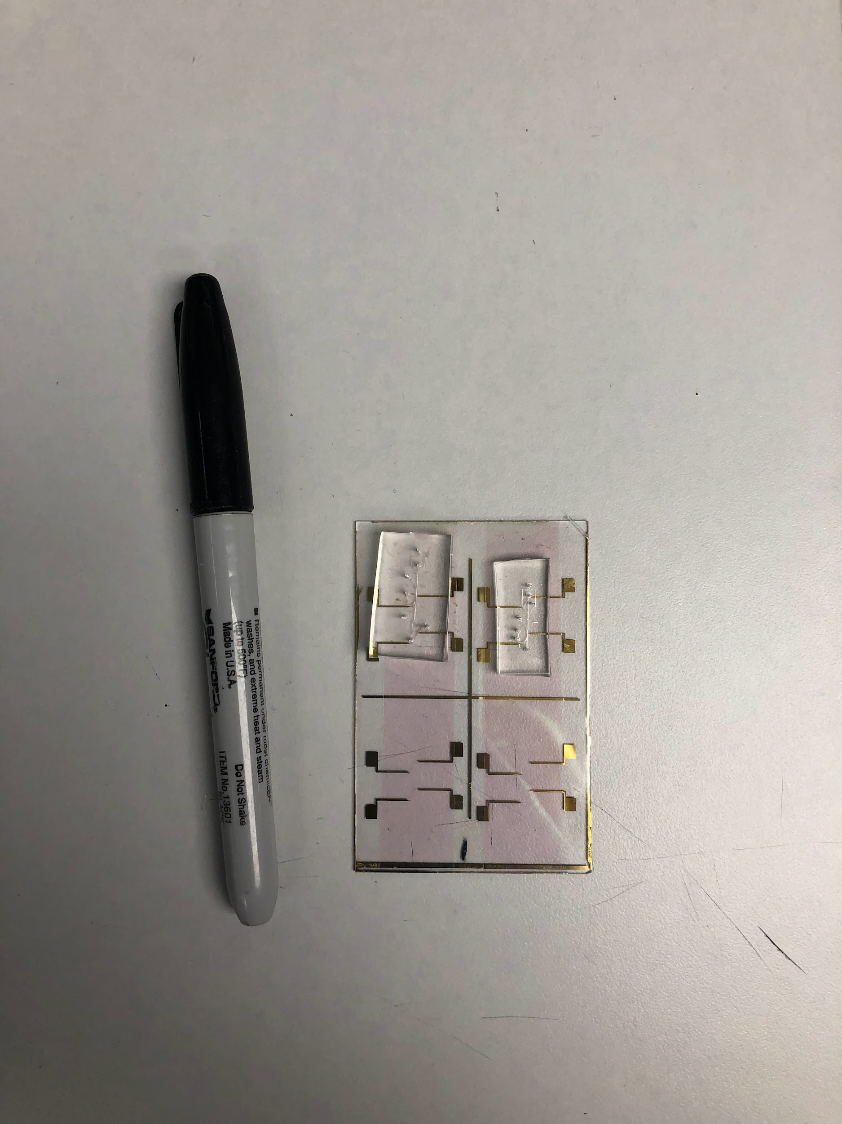

**4. Operation**

To operate this device, several steps need to be taken. Tubing needs to be attached to the holes punched into the device to allow for fluid injection into the channels. A syringe pump equipped with water and oil syringes is needed to inject fluid at steady, controlled rates. A microscope is needed to observe the operation of the device.

The first step in operation/experimentation is ensuring that there are no leakages or blockages. This consists of pushing fluid through the channels and confirming that it exits through the proper output.

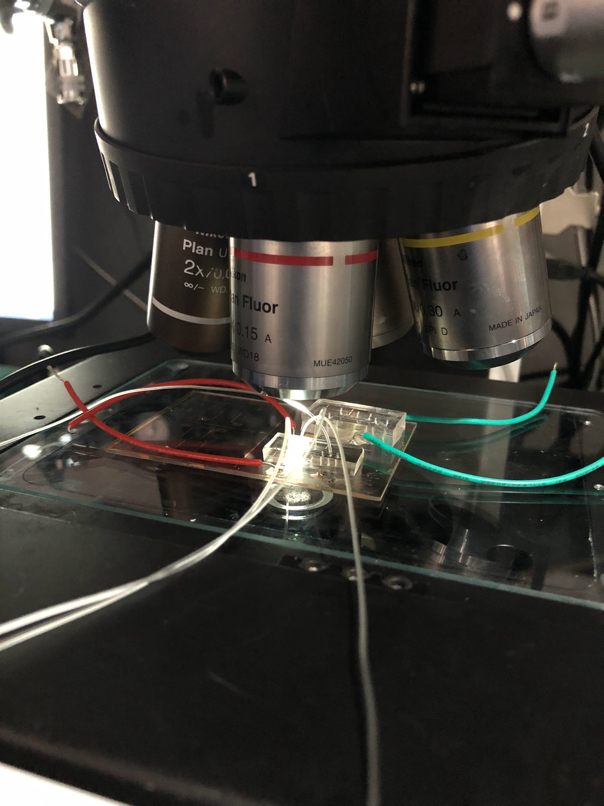

*Figure 5: Device being operated under the microscope, equipped with tubing and wires*

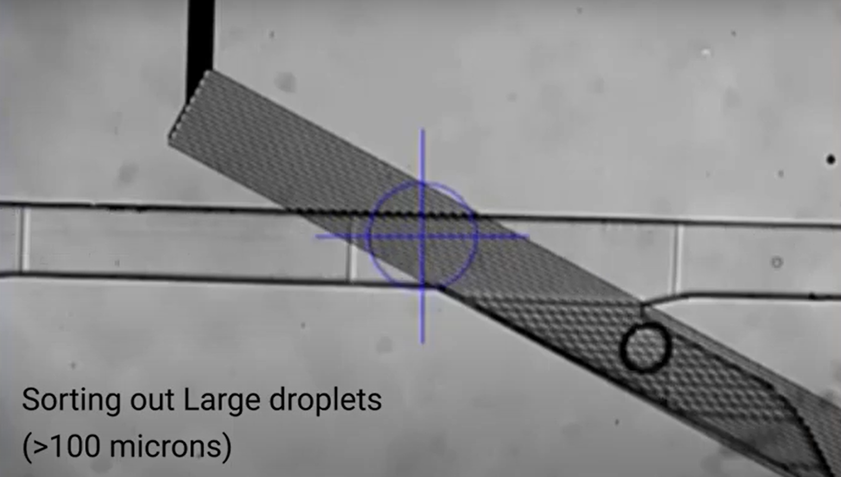

*Figure 6: First stage of the band-pass filter, under the microscope*

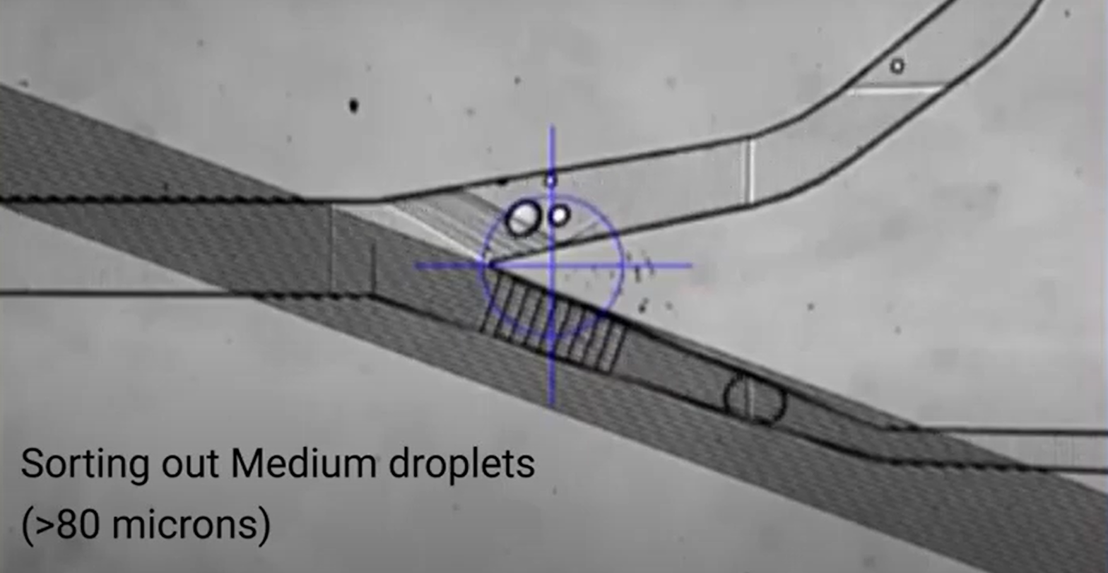

*Figure 7: Second stage of the band pass filter, under the microscope*

**5. Data Collection**

The validation of this subsystem was largely qualitative, ensuring the quality of the device visually under a microscope. For instance, checking that the conductors on the IDE hadn’t been damaged during wet etching and checking that fluid can properly pass through the channels. The only quantitative measure necessary was droplet filtration efficiency.

The lab members collaborating on this project indicated that 90% filtration efficiency is considered sufficient, while 99% is considered excellent. The first stage of this device reaches 93% efficiency and the second stage reaches 92% efficiency. The fluid biasing, a factor that greatly affects filtration, on the bandpass filter is trickier than on the high-pass filter, since there are 2 fluid biasing locations on this device. This is something that is improved through practice while operating the device, so it is expected that these efficiencies will climb through more practice.

| Trial | First Stage | | Second Stage | |
| --- | --- | --- | --- | --- |
| Total number of droplets 100um+ sampled | Droplets 100um+ effectively sorted | Total number of droplets 80um+ sampled | Droplets 80um+ effectively sorted |
| 1 | 100 | 91 | 100 | 92 |
| 2 | 200 | 185 | 200 | 182 |
| 3 | 250 | 232 | 250 | 230 |
| 4 | 500 | 469 | 500 | 462 |
| Total | 1050 | 977 | 1050 | 966 |

*Table 1: Table of experimental results*

**6. Conclusion**

The band-pass filter is an essential component of this device to mitigate the problem of false negative and false positive results in biological experiments involving PCR. The band-pass filter contains two stages of filtration and is part of the larger device. Overall, the band-pass filter is the second filtration stage, coming after the high-pass filter.

**6.1 Learnings**

This project has been very interesting and intellectually stimulating. I had never heard of microfluidics before, and it has been very fun to discover an entirely new area within my field. It is a very interdisciplinary subject, so I have gotten to learn about fluid dynamics, biology, and some chemistry in addition to electrical engineering. One of the highlights of the project has been the fabrication processes and learning to use very specialized and expensive equipment. In addition to all of the technical learnings, I have honed my interpersonal and intercultural communication skills.

**6.2 Future Works**

This semester’s work on the device has consisted of design, fabrication, and validation of the subsystems. Next semester, more experimenting will be required for the joined device. A large focus will be placed on investigating how different IDE parameters affect filtration efficiency – namely manipulating the width and distance apart of the IDE fingers.